**While migrating, you are asked to perform the following**

**tasks:**

1. Create a MariaDB Engine based RDS Database.

2. Connect to the DB using the following ways:

a. SQL Client for Windows

b. Linux based EC2 Instance

Let’s create Rds first->

Search RDS in menu

Click on create database 🡪

Select maria Db in engine.

Select template and version.

Give name and password.

Choose storage and type.

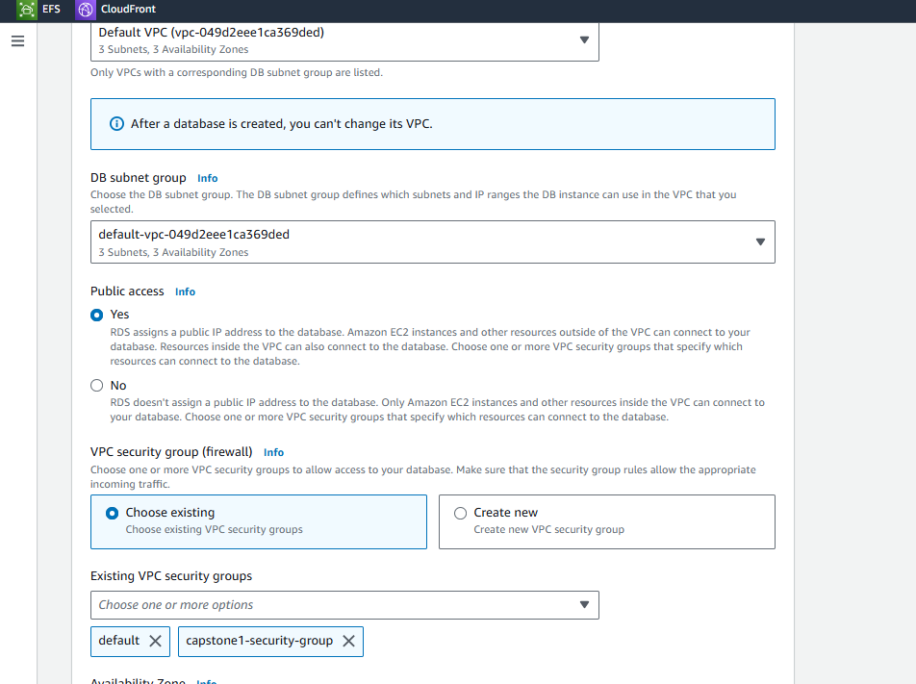

We have make public access true so that we can connect it with our sql client in local.

Give database a name and create it.

We can see our maria DB instance.

Now let’s connect it , open your any sql client in system. Let’s we have db visualizer.

Click on create connection

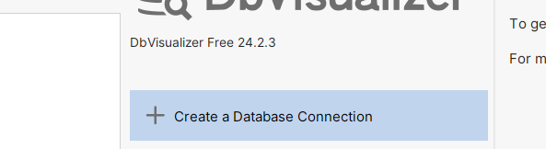

Select mariadb in driver.

Change setting.

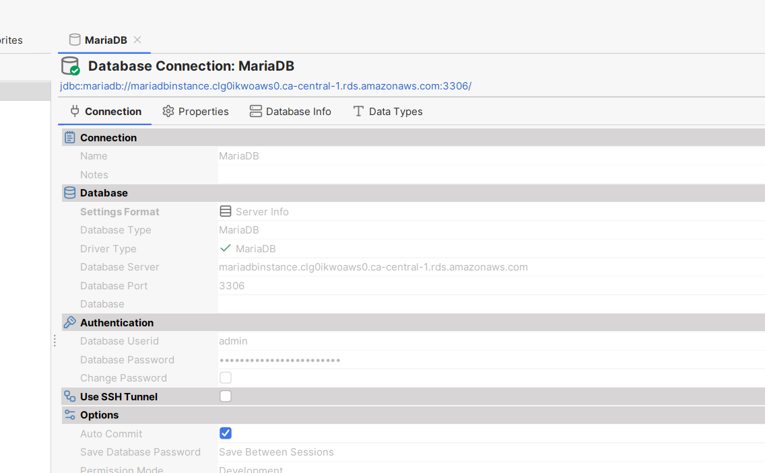

Put sever name of the rds we have created and username /password.

And click on connect

We can see our database we have created and connected.

Now let’s try to connect with ec2 instance.

We already have our ec2 instance lets try to connect it with that.

So to connect it with maria db we need a client so first install that client using command.

sudo dnf install mariadb105

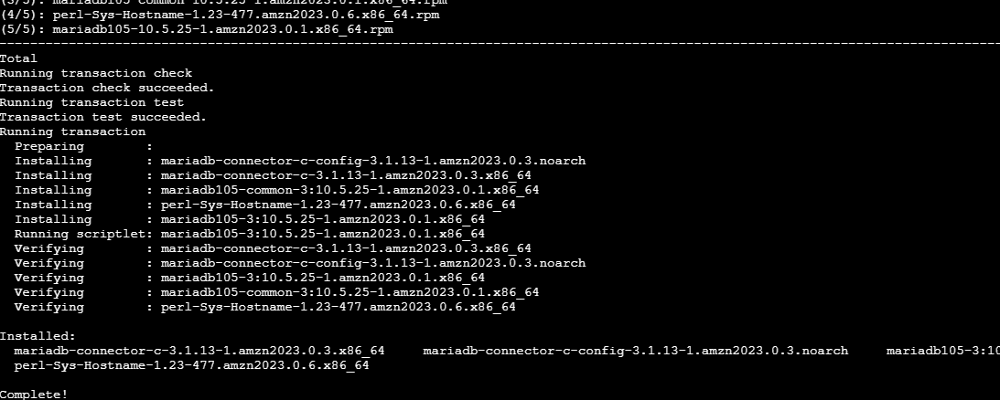

Now trying to connect using command

mysql -h mariadbinstance.clg0ikwoaws0.ca-central-1.rds.amazonaws.com -P 3306 – u admin -p

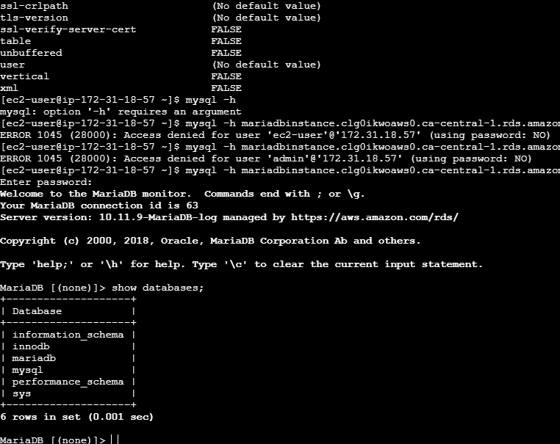

We can see a successful connection.